Grade 7 Accelerated · Unit 4 · Lessons 7–8  Real-World Order of Operations  Question Bank - Additional 4.07 ANSWER KEY | Name  Date  Period

Show your work. Circle your final answer.
For questions 1 through 4, substitute and evaluate.
1. 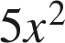 when 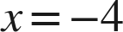
80
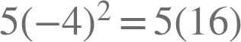.

2.  when  and 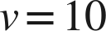
1,500
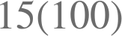.

3. 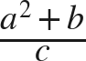 when 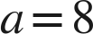, 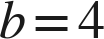, 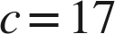
4
The bar groups the whole numerator: .

4. 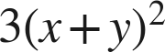 when 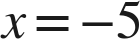 and 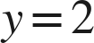
27
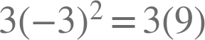.

For questions 5 and 6, write and evaluate an expression. Give the unit.
5. A square room of side 13 feet is floored at 2.75 dollars a square foot, with a flat 90 dollars for delivery. Find the total cost.
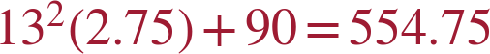 dollars

6. A rectangular patio 16 feet by 7 feet is sealed at 1.40 dollars a square foot, with a flat 35 dollars for equipment hire. Find the total cost.
dollars
The area is 112 square feet.

Two formulas.
7. Body mass index is 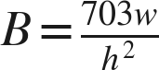, where is a weight in pounds and is a height in inches. Find  to the nearest tenth.
a. , 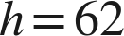
21.9
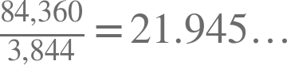
b. 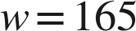, 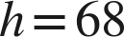
25.1
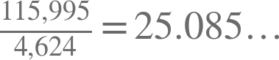
c. , 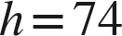
27.0
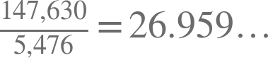

8. Kinetic energy is , for mass in kilograms and speed in metres per second. Find  in joules.
a. 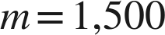, 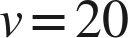
300,000 joules
b. , 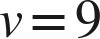
25,920 joules
c. 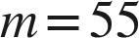, 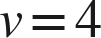
440 joules

Working backwards.
9. Find the missing value in each situation.
a. 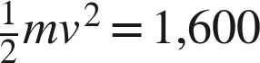 and 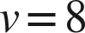. Find .
m = 50
.
b. 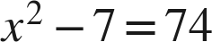, where is positive. Find .
x = 9
c. A square lawn of side feet is turfed at 3.00 dollars a square foot with a flat 55 dollars delivery, and the total is 1,255 dollars. Find .
n = 20
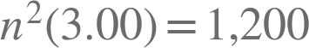, so 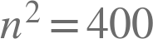.

Reading the situation.
10. Two problems use the numbers 8, 12 and 4. A: a printer costs 8 dollars to hire plus 12 dollars for each of 4 days. B: a printer costs 8 dollars for each of 12 reams, plus 4 dollars for delivery. Find both totals, and explain why circling the numbers would not have told you what to do.
A is  dollars. B is  dollars. The two problems carry the same three numbers, so the numbers cannot be what decides; what decides is which amount is repeated and how often.
Ask which number is a rate in each problem — that question has a different answer in A and in B, and no marking on the page can show it.

11. A square court of side 20 feet is resurfaced at 3.60 dollars a square foot, with a flat 200 dollars for the equipment. Which expression gives the total cost?
○ A. 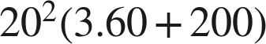
○ B. 
● C. 
○ D. 
C

12. Select ALL of the expressions whose value is 32 when .
☒ A. 
☒ B. 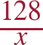
☐ C. 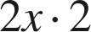
☒ D. 
☐ E. 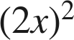
☒ F. 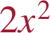
A, B, D and F

